Roots
Name: Hour Date:
Date Packet is due: Why late? Score:
^{Day of Week Date} If your project was late, describe why
Overview: In this unit, students will investigate how plants are able to acquire water and minerals from the soil and distribute these substances to each cell in the plant.
Semester Schedule
Week 1: Introduction & Lab Safety
Sustainable Soils
Week 2: Sustainable Ag
Week 3: Soil Science
Week 4: BMPs
Week 5: Unit Project
Plant Physiology
Week 6: Roots
Week 7: Stems
Week 8: Leaves
Week 9: Plant Systems
Week 10: Unit Project
Plant Environments
Week 11: Light
Week 12: Temperature
Week 13: Water
Week 14: Biodiversity
Week 15: Unit Project
Gardening
Week 16: Gardening 101
Week 17: Final Project
Week 18: Final Exam

Main Questions
- How do plant roots acquire water and minerals from the soil?
- How do plant roots create concentrations of minerals that are hundreds of times greater than the surrounding soil?
- How do plants transport water and minerals from the roots to the rest of the plant?

Weekly Schedule

Monday:
- Diffusion PhET Simulation
- Water Lab
- Model development – How do plants acquire and transport water and minerals?

Tuesday:
- Nutshell Video & Notes
- Class discussion & revisions of explanations

Wednesday:
- Sad Radishes Lab

Thursday:
- Review
- Group Quiz

Friday:
- Weekly Reflection
- Career & Community Connections

This material is based upon work supported by the National Science Foundation Graduate Research Fellowship Program, Grant No. DGE-1424871. Any opinions, findings, and conclusions or recommendations expressed in this material are those of the author(s) and do not necessarily reflect the views of the National Science Foundation.

Day 1: PhET Diffusion Simulation
Introduction: In this activity, you will be using a computer simulation to investigate how diffusion occurs across permeable and semi-permeable cell membranes. This will provide you with some initial ideas in regards to how plant roots are able to acquire water and minerals.

Materials Needed: a computer or device with internet access
Directions: Complete the questions below. Then complete the activity directions on the next page.
- A plant has to acquire water and minerals from the soil in its roots, create concentrations of these substances that are hundreds of times greater than the surrounding soil, and then move these substances against gravity to every other cell in the plant. How do you think that plants are capable of doing this? Briefly summarize your initial ideas below for each aspect of this question. Note: it’s ok to be wrong here – you’re just speculating for now.
How plants acquire water and minerals from the soil:
How plants create high concentrations of minerals inside its cells:
How plants move water and minerals against gravity to other cells:
Open the PhET Membrane Channel Simulation on a computer or personal device (as indicated by your instructor). Use the instructions provided by your instructor (as found in the appendix of this packet) to guide you throughout this activity. In the first activity in this simulation, you will observe diffusion as it occurs in a “leaky membrane”, or a cell that is completely porous to these substances. Complete Part A in the instructions and then answer the questions below.
- What happened to the concentration of blue and green substances on either side of the membrane over time?
- This activity demonstrates how diffusion occurs at the molecular level. Based on your observations, how would you define “diffusion” in your own words?
Move on to Part B in your instructions. In this portion, you will observe a membrane that has gated protein channels. These are proteins that can selectively regulate what substances enter and leave the cell. Complete the questions below after you have completed Part B.
- How did the outcome of Part B differ in comparison to Part A? Describe your observations below:

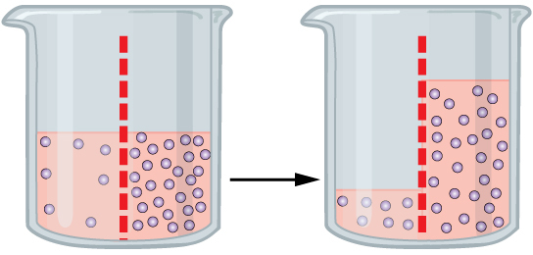
- In this simulation, the green and blue substances did not appear to exert any kind of influence on each other. How might the outcome be different if the blue substance was chemically attracted to the green substance? Would the concentrations of the blue substance be similar or different on either side of the membrane (assuming that all the green substance was on the top side of the membrane)? Explain:
- The image at the right shows a before-and-after image of a beaker containing water and a semi-permeable barrier. This barrier allows water to pass freely but blocks the movement of salt particles. The concentration of the salt particles is greater on the right than it is on the left. In the space below, explain why you think that the water is displaced (i.e. why is more water on the right side of the barrier than on the left in the right image?).
- Does this evidence change any of your ideas about how plants acquire water and minerals in their roots and/or how plants distribute water and minerals to other parts of the plant? Summarize your ideas below:

Day 1: Water Lab
Introduction: In this activity, you will be observing how capillary action occurs using a beaker of water and narrow tubes. This will provide you with some evidence to guide you in developing explanatory models for how plants are able to distribute water and minerals to every cell.

Materials Needed: a 1000 ml beaker (or cup or other similar-sized vessel for holding water); tap water; differently-sized clear tubing and/or straws; food dye.
Directions: Make sure your beaker or cup is completely clean. Fill your beaker or cup half-full with tap water. Add one drop of food dye and observe how the dye interacts with the water. Record your observations below.

- How did the food dye change when it was added to the water? Did it remain as a single drop of dye or did it start to disperse throughout the water? Why do you think that this occurred?
Next, insert your tubing and straws into the beaker or cup. Allow water to move into the tube or straws (this might take a few seconds – if air is trapped inside the tube or straw, you may need to push it out by running the tubing or straw under a faucet for a couple seconds).
- Does the water inside the tubing and straws sit at the same level as the water in the beaker or the cup, or is the water inside the tubing/straws at a different height?
- You should have tubing and/or straws that have differently-sized openings. Does this affect the height at which the water sits inside the straw? Describe your observations below.
- How would you explain these observations? List your initial ideas below and back your claims with evidence and/or reasoning.
- Does this change any of your ideas for how a plant acquires water and minerals, increases the concentration of these substances, and/or moves these substances throughout the plant? Explain:
- Be sure to clarify your ideas as a group and have clear evidence and reasoning to back your claims. Be prepared to report your group’s ideas in a whole class discussion.
- Based on the ideas you heard in the whole-class discussion, what are your most up-to-date ideas in regards to how plants acquire, concentrate, and distribute water and minerals to its cells?
How plants acquire water and minerals from the soil:
How plants create high concentrations of minerals inside its cells:
How plants move water and minerals against gravity to other cells:
- What questions do you have as a result of these activities in regards to these topics? List three questions that emerged as a result:

Day 2: Notes & Discussion
Introduction & Directions: In this activity, you will begin by watching a short video about roots. This will help to clarify some of the questions you may have had yesterday. After the video, you will look at a short slideshow presentation that will provide you with specific information. Your instructor may decide to deliver the presentation as a classroom lecture or they may allow you to read the notes individually or in small groups (depending on your previous experience and capabilities with this content). After you have watched the video and finished with the slideshow, you will work in small teams to answer the questions listed below. You should take notes in a notebook, online, on a dry erase board, or on scratch paper so that you are prepared to deliver your responses during the class discussion that will follow. Note: your instructor may assign your group to answer specific questions if time is limited.

URL Links
YouTube Video: https://youtu.be/-nHO3SAsePE ; https://www.youtube.com/watch?v=mfDPOfW244k

Slideshow Presentation: XXXX (or visit www.factsnsf.org and use the menu bar).

Discussion Questions:
- Why are roots important to plant productivity?
- Why is root function an important consideration for sustainability in agriculture?
- What are the 3 key functions of all roots? What is a fourth function in some plants?
- Briefly describe the role that each of the following serves in a plant’s roots: 1) Root Cap; 2) Meristem; 3) Cortex; 4) Root Hairs; 5) Vasculature; 6) Epidermis; 7) Endodermis
- What is the Casparian strip and how does it support plant function? What would happen if a plant was unable to form a Casparian strip? List at least three outcomes.
- Briefly summarize each of the following: 1) diffusion; 2) active transport; 3) transpiration.
- Explain how water and minerals initially enter the root cells. In your explanation, be sure to include the following terms: diffusion, permeable, epidermis, and cortex.
- How are plants able to create concentrations of minerals such as K+ and N that are up to hundreds of times greater than what is found in the soil? In your explanation, be sure to include the following terms: active transport, proton pumps, hydrogen ions, charge.
- What are xylem and phloem? How are they similar and how do they differ?
- How are plants able to move water and minerals to every cell without using pumps or expending energy, even in the tallest of trees? In your explanation, be sure to include the following terms: xylem, transpiration, cohesion, adhesion.
- Summarize the processes that enable water and minerals to move from the soil to uppermost parts of the plant.
- How can plant productivity be improved through biodiversity? Provide three examples.
- Why would plants roots be less productive in compacted soils compared to porous soils?
- Why would both flooded soils and overly dry soils impair root function?
- How does soil organic matter affect root function?
- What is an ideal pH for soils in regards to root function? Explain.
- How does temperature affect root function?
- Why might increasing the number of plants in a field or garden reduce crop yields?

Day 3: Lab – Sad Radishes
Introduction: In this activity, you will predict the effects of different soil treatments on the function of radish roots. You will then use your knowledge of root function to identify which radishes are in each kind of soil treatment.
Materials Needed: your instructor will provide you with the treated radish seedlings using instructions from the appendix of this packet. You will also need this worksheet and a pen or pencil.

Pre-Activity Questions (complete in your groups before working with the actual radish seedlings):
- For each of the following summarize what visible observations you would expect to make. Justify this with reasoning or evidence from this unit.
  - Compacted soil (minimal porespace):
Expected visible observations:
Reasoning:
  - Large soil particles (sand):
Expected visible observations:
Reasoning:
  - Small soil particles (clay):
Expected visible observations:
Reasoning:
  - Soil w/ high salinity (salt content):
Expected visible observations:
Reasoning:
  - Flooded soil:
Expected visible observations:
Reasoning:
- Activity Questions: your instructor should provide you with radish seedlings in soil that has undergone the specific treatments. As groups, use the space below to determine which seedlings are in different kinds of treated soil (your instructor should provide a list of these treatments to you on the board or elsewhere). Be prepared to defend your answers as a group to the entire class.

Day 4: Review & Assessment
Directions: you will begin by reviewing the unit objectives in your small groups. For each objective, rank it as a 1 (completely unsure), 2 (somewhat unsure), or 3 (completely sure) based on your comfort with that objective. After a few minutes of review, your instructor will lead a whole-class review. This is your chance to ask any questions you still might have about the concepts in this unit. Begin with anything you ranked as a “1”.
After you have completed the unit review, you will be taking an individual multiple choice quiz and/or a group short answer quiz. These quizzes may be graded in class to help you better understand the question and the correct answer.

Unit Objectives:
- Why are roots important to plant productivity?
- Why is root function an important consideration for sustainability in agriculture?
- What are the 3 key functions of all roots? What is a fourth function in some plants?
- Briefly describe the role that each of the following serves in a plant’s roots: 1) Root Cap; 2) Meristem; 3) Cortex; 4) Root Hairs; 5) Vasculature; 6) Epidermis; 7) Endodermis
- What is the Casparian strip and how does it support plant function? What would happen if a plant was unable to form a Casparian strip? List at least three outcomes.
- Briefly summarize each of the following: 1) diffusion; 2) active transport; 3) transpiration.
- Explain how water and minerals initially enter the root cells. In your explanation, be sure to include the following terms: diffusion, permeable, epidermis, and cortex.
- How are plants able to create concentrations of minerals such as K+ and N that are up to hundreds of times greater than what is found in the soil? In your explanation, be sure to include the following terms: active transport, proton pumps, hydrogen ions, charge.
- What are xylem and phloem? How are they similar and how do they differ?
- How are plants able to move water and minerals to every cell without using pumps or expending energy, even in the tallest of trees? In your explanation, be sure to include the following terms: xylem, transpiration, cohesion, adhesion.
- Summarize the processes that enable water and minerals to move from the soil to uppermost parts of the plant.
- How can plant productivity be improved through biodiversity? Provide three examples.
- Why would plants roots be less productive in compacted soils compared to porous soils?
- Why would both flooded soils and overly dry soils impair root function?
- How does soil organic matter affect root function?
- What is an ideal pH for soils in regards to root function? Explain.
- How does temperature affect root function?
- Why might increasing the number of plants in a field or garden reduce crop yields?

Day 5: Career Connections
Directions: Begin with a group and class discussion about the topics of this week. What is still unclear? What is still confusing? What seemed most important to remember? How does this relate to horticulture?

If time allows, you will also have time to work on one or two semester projects:

The Garden Project involves creating your own garden as a group. Your instructor will provide you with more details, but in a nutshell you will work as part of a team to plan, design, and create some kind of garden. This might be a community garden, a school-based garden, or a container garden. The goal is to utilize the knowledge and practices that you gain over the course of this semester to maximize the productivity and sustainability of your garden.

The Adopt a Farmer Project involves working with a farm, greenhouse, or community garden in your community in order to determine some new methods that they could try to improve the sustainability of their operation. Your instructor will provide you with more details about this project.

Roots Individual Quiz
Name: Hour Date: Score: /
Directions: This quiz should be completed on an individual basis. A 3x5 notecard with handwritten notes can be used on this quiz.
- All roots have three key functions. List those in the space below.
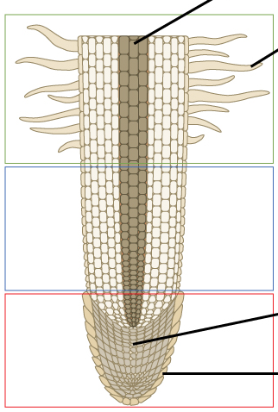
A
- For each of the following, write the name of the part of the root next to the appropriate letter based on the image at the right.
B
  - ___________________________________
C
  - ___________________________________
D
  - ___________________________________
E
  - ___________________________________
  - ___________________________________
F
  - ___________________________________
G
  - ___________________________________
Word bank: Cortex, Endodermis, Epidermis, Meristem, Root Cap, Root Hair, Vasculature
- Imagine a plant that lacks a Casparian strip as the result of a genetic mutation. Which of the following might be a possible outcome in this scenario?
  - The plant is unable to maintain concentrations of water and minerals that are higher than the surrounding soil.
  - The plant is at greater risk from pathogens and toxins.
  - The plant would be unable to supply a sufficient amount of water and/or minerals to the rest of its cells.
  - All of the above are possible outcomes.
  - None of the above are possible outcomes.
- This describes the evaporation of water from the surface of the plant.
  - Diffusion b. Active Transport c. Transpiration d. Adhesion e. Cohesion
- This is when a substance distributes evenly throughout a solution.
  - Diffusion b. Active Transport c. Transpiration d. Adhesion e. Cohesion
- This when root cells use chemical energy to create higher concentrations of substances.
  - Diffusion b. Active Transport c. Transpiration d. Adhesion e. Cohesion
- This is when water molecules are attracted to other water molecules.
  - Diffusion b. Active Transport c. Transpiration d. Adhesion e. Cohesion
- This is how water and minerals initially enter the cortex of the roots.
  - Diffusion b. Active Transport c. Transpiration d. Adhesion e. Cohesion
- This is primary way in which plants move water from their roots to upper portions of the plant.
  - Diffusion b. Active Transport c. Transpiration d. Adhesion e. Cohesion
- This is primarily how plants create higher concentrations of water and minerals than the surrounding soil.
  - Diffusion b. Active Transport c. Transpiration d. Adhesion e. Cohesion
- Hugh, Dewey, and Louise are debating how plants are able to move substances like water, minerals, and sugars to each cell. Hugh suggests that plants must have a pump similar to how many animals have a heart. Dewey disagrees, and says that the high mineral content in the cells moves water to the top of the plant. Louise suggests that evaporation of water from pores in the leaves does most of the work of moving water and minerals, and that sugars are able to move down from the leaves with gravity. Who do you think has the most accurate description?
I think that has the most accurate description because
- Root cells have concentrations of water and minerals that are hundreds of times greater than the surrounding soil. What enables plants to be able to create these high concentrations?
  - Minerals diffuse into the plant cells on their own, creating high concentrations without the need to expend any energy.
  - Root cells pump out positively-charged hydrogen atoms, creating a negatively-charged cell interior that attracts minerals like potassium (K+).
  - Root cells actively pump in specific kinds of minerals like K+ and NO3-.
- How do xylem and phloem differ?
  - Xylem uses a pump to move water and minerals up the plant; phloem uses gravity to move water and sugars down from the leaves.
  - Xylem depends on transpiration to move water and minerals up the plant; phloem uses gravity to move water and sugars down from the leaves.
  - Xylem uses proton pumps to move water and minerals, whereas phloem uses transpiration.
- Which of the following describes mycorrhizae?
  - Bacteria that turn nitrogen in the air into versions that plants can utilize.
  - Organisms that create humus in the soil.
  - Fungi that increase the surface area of roots, improving the absorption of water and minerals.
  - Plants that are able to use bacteria to fix nitrogen.
- Which of the following describes rhizobia?
  - Bacteria that turn nitrogen in the air into versions that plants can utilize.
  - Organisms that create humus in the soil.
  - Fungi that increase the surface area of roots, improving the absorption of water and minerals.
  - Plants that are able to use bacteria to fix nitrogen.
- Which of the following describes legumes?
  - Bacteria that turn nitrogen in the air into versions that plants can utilize.
  - Organisms that create humus in the soil.
  - Fungi that increase the surface area of roots, improving the absorption of water and minerals.
  - Plants that are able to use bacteria to fix nitrogen.
- A gardener is trying to adopt some practices to improve the performance of their crops. Which of the following practices would NOT improve root function?
  - Avoiding practices that cause soil compaction and reduce soil porespace.
  - Adding mulch and other organic matter to the soil.
  - Using covers over the garden beds that keep the soil warm for longer periods of time.
  - Arranging the plants as densely as possible in each garden bed.
  - Closely watching soil moisture to keep it from getting overly dry or wet.

Roots Group Quiz
Names (F&L):
Hour Date: Score: /
Directions: This quiz should be completed in your assigned groups. A 3x5 notecard with handwritten notes can be used on this quiz. Each person should take turns writing an answer. Those not writing should be actively working together to create their group’s answer. Those who are not actively involved in answering every question may be asked to complete this quiz alone. Record the writer’s name after each question.
- Plants depend on diffusion, active transport, and transpiration to acquire water and minerals from the soil and distribute these substances throughout the plant. Briefly summarize how these processes enable the movement of water and minerals to occur.
Writer’s Name:
- Plants have to acquire water and minerals in higher concentrations than the surrounding soil while also keeping out pathogens and toxins. Summarize how the following enable this to occur: epidermis; cortex; endodermis; Casparian strip; vasculature (xylem).
Writer’s Name:
- Biodiversity is important for root function. Briefly summarize three ways in which soil biodiversity can improve root function and plant productivity.
Writer’s Name:
- Conventional crop production generally utilizes regular tillage, which reduces the amount of porespace in the soil. Tillage also increases the decomposition of organic matter, resulting in an average of 1000 lbs. of lost soil organic matter per acre per year. This also reduces the biodiversity of soil organisms. Explain how this could affect root function in crops in a manner that would increase the need for inputs such as fertilizers and irrigation.
Writer’s Name:

- Briefly describe how the implementation of these practices could potentially improve the root function of a crop.
Reduced tillage:
Reduced tillage is when farmers minimize soil disturbance by reducing how frequently they plow their fields. This can improve soil porespace.
Nutrient management plans:
Crop Nutrient Management is a practice which matches nutrient application to a field with a crop’s need for nutrients.
Increasing soil organic matter levels:
Cover Crops:
Cover crops are planted after the main crop is harvested to reduce erosion. Hint: cover crop roots remain in the soil after the crop is no longer needed.

Writer’s Name:

Appendix: PhET Membrane Channels Diffusion Simulation
Note: copies of these instructions should be made available to your students during the activity.
Introduction: The PhET Membrane Channels Simulation allows you to observe how diffusion occurs at the atomic scale. Using the PhET Simulation, you will investigate three questions:
1. How do the concentrations of substances change as a result of diffusion?
2. How do membranes and protein channels affect the rate diffusion?
3. How do diffusion, membranes, and protein channels affect absorption of water and minerals in roots?

Ordinarily, it would be impossible to directly observe the interactions of atomic-level substances. The PhET simulation serves as a model to make these interactions visible. This can help us explore patterns that are otherwise hard to see.

Downloading the PhET Simulation: you will need download it onto the computers or devices that your students will be using. For the file and for instructions on how to download, visit https://phet.colorado.edu/en/simulation/membrane-channels

- How do the concentrations of substances change as a result of diffusion?
Open the PhET Membrane Channels simulation. On the lower center portion of the screen, move the knob to the “fast” side of the slider. On the right side of the screen, select the box that says “Show Concentrations”. Your screen should look like the image below:
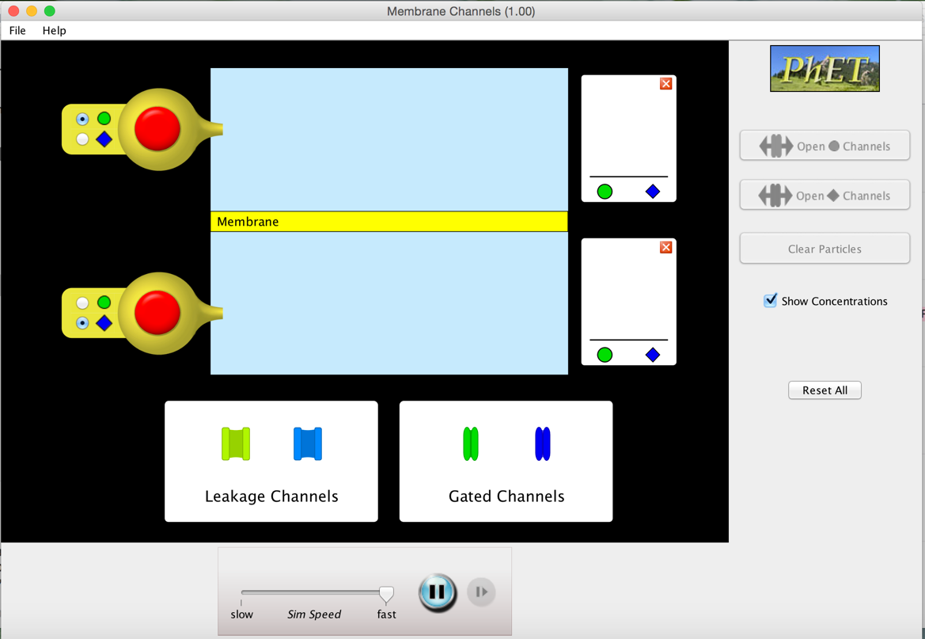
Click and drag two green leakage channels and two blue leakage channels onto the “membrane” (the yellow rectangle in the center of the blue screen). Click the upper red button 20 times to release twenty green “molecules” into the upper portion. Click the lower red button 20 times to release twenty blue “molecules” into the lower portion. After one minute, record your observations. Your screen should look like the image below:
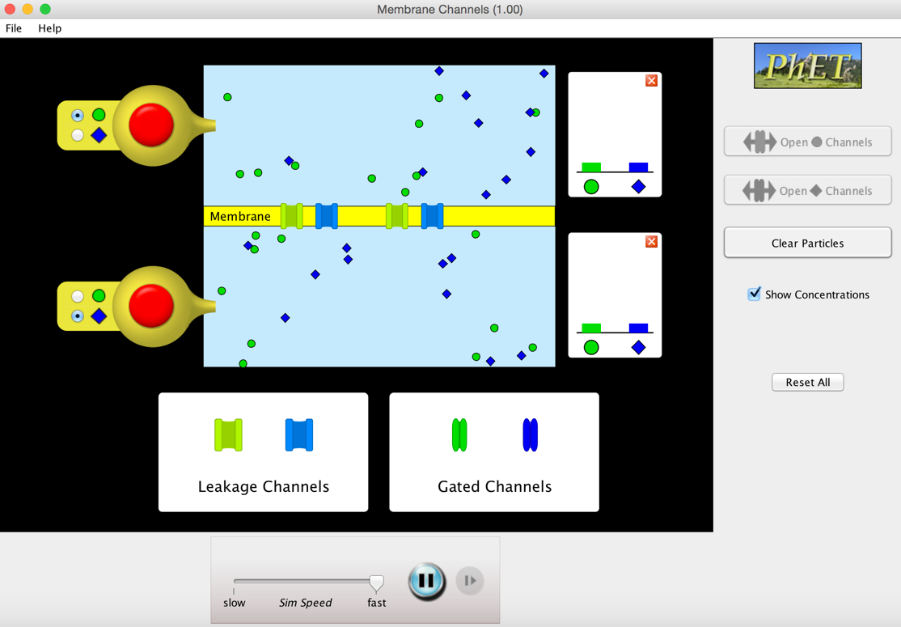
B. How do membranes and protein channels affect the rate diffusion?
On the right-hand side of the screen, click “Reset All”. Once again, move the knob to the “fast” side of the slider. On the right side of the screen, select the box that says “Show Concentrations”. Click and drag two green gated channels and two blue gated channels onto the “membrane”. Click the upper red button 20 times to release twenty green “molecules” into the upper portion. Click the lower red button 20 times to release twenty blue “molecules” into the lower portion. After one minute, record your observations. Your screen should look like the image below:
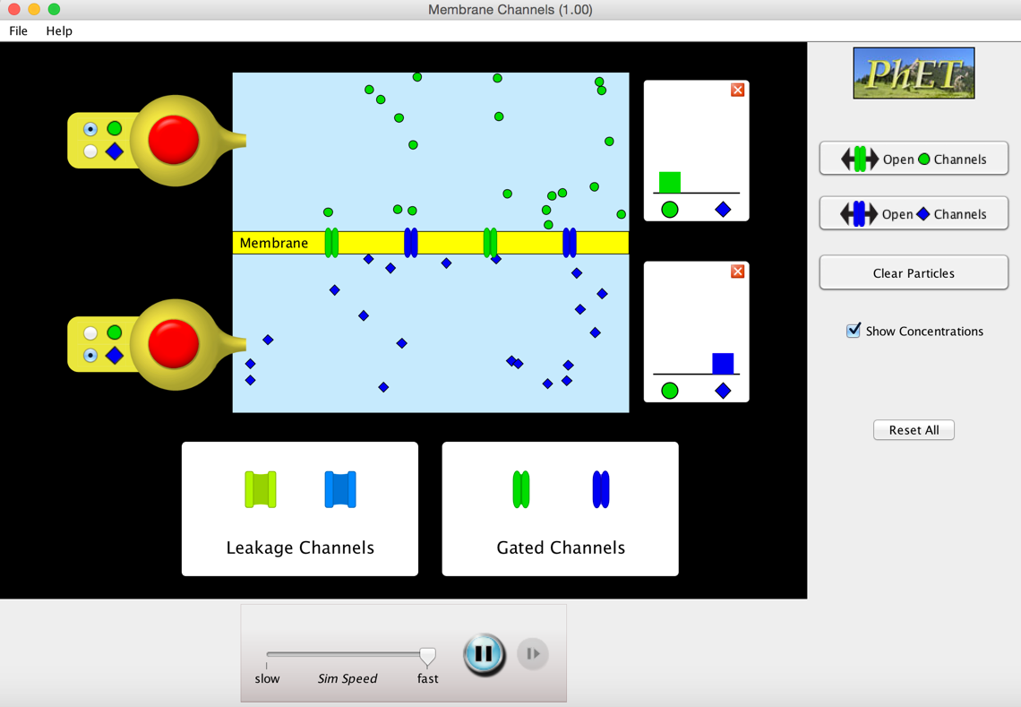

Next, click “Open ◆ Channels” on the right-hand side of the screen to open all of the blue protein channels. Do NOT open the green channels (i.e. do NOT click “Open ● Channels”). Observe what happens and after one minute, record your observations. Then answer the accompanying questions.

Appendix: Water Lab
Introduction: The purpose of this activity is to enable students to develop explanatory models about cohesion and adhesion of water molecules as well as enable students to further develop their ideas regarding diffusion.

Materials Needed: a 1000 ml beaker (or cup or other similar-sized vessel for holding water); tap water; different-sized clear tubing and/or straws; food dye.

Directions: Students should be able use the step-by-step instructions in the packet to complete the activity. You may want to model this first step of this activity using a computer projector if your students need additional support. Generally speaking, this lab is pretty simple and straightforward – students will observe food dye as it disperses in water and will observe capillary action in differently-sized tubes or straws. The intent is for students to begin to grasp how xylem is able to transport water up against gravity as a result of transpiration, adhesion, and cohesion. Students are likely to correctly guess the outcomes before they occur, and that is fine – the key is for this lab to serve as a stepping stone for more complex ideas in regards to water and mineral transport in plant vasculature.

Note: as an instructor, you may opt to modify this lab by adding additional options, such as showing how cohesion enables a siphon to work.

Appendix: Sad Radishes Lab (needs to be started two weeks in advance!)
Introduction: In this activity, students will attempt to determine how different soil treatments such as compaction, particle size, organic matter, mineral content, and other factors affect the capacity for radish seedlings to function.

Note that you will need to start the radish seedlings in the soil treatments roughly two weeks in advance.

Materials Needed: seedling trays, radish seeds, potting soil, playground sand, high-clay soil, table salt, water.

Instructions: 2-3 weeks prior to the lab activity, plant radish seeds using standard six-pack seedling trays (one seed per compartment). Trays should be filled with soil based on the categories below:
- Normal: fill each compartment with standard potting soil. Add porous substances like vermiculite if not already present.
- Large soil particles: fill each compartment with playground sand (if possible, filter the sand with cheese cloth to remove smaller particles).
- Small soil particles: fill each compartment with high-clay soil.
- Soil Compaction: fill each compartment with standard potting soil. Compress the soil with your fingers after the seedlings emerge
- Flooded: fill each compartment with standard potting soil. Keep the soil water logged once the seedlings emerge by placing the six-pack seedling tray in a tray of water.
- Saline Soils: fill each compartment with standard potting soil. Add table salt after the seedlings emerge (ideally at different rates per compartment).
- Extra options: consider creating treatments of your own.
You may choose to produce replicates of each treatment if needed. Be sure to label each seedling tray with the treatment applied to it. Keep these labels hidden so that students cannot see this in advance. Students should use the accompanying worksheet in this packet to predict the effects of each treatment on radish root function and then try to identify each tray based on the condition of the radishes. Time should be reserved at the end for group and whole-class discussion in which students engage in evidence-based argumentation to defend their ideas and connect the activity to specific concepts from this unit. A potential itinerary could be as follows:
- Introduction: provide students with an overview of the activity. Model their expected performances if needed.
- Group Work Time - Predictions: have students complete the accompanying activity’s questions (in the packet) in which they predict how each treatment would affect root function.
- Group Work Time - Identification: provide time for groups of students to move from seedling tray to seedling tray and attempt to identify which treatment was applied to each. Students should record this in their activity packet. Be sure to provide a list of the soil treatments you utilized in writing.
- Whole-Class Discussion: ask for student groups to defend their predictions and choices and engage students in sense-making discussion using options such as the Nine Talk Moves. You may choose to not reveal the answers and insist that students determine for themselves which treatments were applied.

