Individual Sustainability
Name: Hour Date:
Date Packet is due: Why late? Score:
^{Day of Week Date} If your project was late, describe why
Overview: in this unit, you will be using self-assessments and other resources to both determine the sustainability of your own lifestyle while identifying specific ways in which you can make your life more sustainable.
Semester Schedule
Week 1: Introduction & Lab Safety
Atoms to Ecosystems
Week 2: Matter & Energy
Week 3: Cell Biology
Week 4: Biodiversity, Ecosystem Services
Week 5: Biodiversity & Habitats
Week 6: Midterm Assessments
Causes of Extinction
Week 7: Extinction
Week 8: Habitat Loss
Week 9: Invasive Species
Week 10: Land & Water Pollution
Week 11: Atmospheric Pollution
Week 12: Overharvesting
Week 13: Midterm Assessments
Sustainable Societies
Week 14: Natural Resources Management
Week 15: Societies & Sustainability
Week 16: Individual Sustainability
Week 17: Personal Campaigns
Week 18: Personal Campaigns

Main Questions
- How sustainable is my own lifestyle?
- In what ways do my own actions and decisions affect the planet’s biodiversity, ecosystem function, and carrying capacity?
- What are the consequences of my own unsustainable behaviors?
- What are some specific changes I could adopt to make my own lifestyle more sustainable?
- How will these changes affect the quality of my day to day life? Could they improve my own happiness and well-being?

Weekly Schedule

Monday:
- Introduction of the Activity.
- Predictions about personal sustainability & discussion.
- Work time to complete sustainability assessments.

Tuesday:
- Work time to complete sustainability assessments.
- Team discussion – how sustainable is your lifestyle?
- Class discussion.

Wednesday:
- School Bus Carbon Footprints Activity

Thursday:
- Complete School Bus Carbon Footprints
- Develop Individual Action Plans

Friday:
- Weekly Reflection.
- Feedback from Day 1 of Individual Action Plans
- Career Connections OR additional work time.

This material is based upon work supported by the National Science Foundation Graduate Research Fellowship Program, Grant No. DGE-1424871. Any opinions, findings, and conclusions or recommendations expressed in this material are those of the author(s) and do not necessarily reflect the views of the National Science Foundation.

Day 1-2: Individual Sustainability Assessments
Directions: This activity has two parts. In the first part, you will be begin in your teams to discuss the following questions:
- How sustainable is my own lifestyle? What evidence can I use to make the claim that my lifestyle is/is not sustainable?
- What are aspects of my lifestyle that are definitely unsustainable? How do I know?
- If more people lived like I did, would the world as a whole be more or less sustainable?
- To what extent do I have an obligation to become more sustainable?
After your team has had time to adequately discuss these questions and how they apply to each team member, the class will come back together for a full discussion. Try to reach a consensus as a class – as a society, to what extent are our lifestyles sustainable? What are some common aspects of our lifestyles that definitely unsustainable? What can and what should we do about this?

After the team and class discussion, you will be completing the sustainability assessments below. These are quantitative estimations of how sustainable your lifestyle is in regards to specific considerations such as water use, carbon pollution, and generation of plastic waste.

Keep in mind that these calculators are far from perfect. A lot of assumptions have to be made to make a calculator that will be feasible for the general public to use; as such, each calculator has critical limitations to their accuracy. Think of these calculators as being valuable as more of a general, ballpark assessment about your life rather than a scientifically-valid finding.

Also keep in mind that these calculators may reflect some biases of the people who created them. You may disagree with some of their conclusions, and that is ok. A crucial component of media literacy is the ability to consider competing claims and the evidence used to support them in comparison to your own ideas and evidence. If you find that you disagree with a claim, remember to ask yourself the ‘scientist’s questions’:
- How do I know that I am not wrong?
- How do I know that what I think will always be the case in every scenario?
The sustainability assessment calculators can be found below. Be sure to complete the questions on the next page as you complete these assessments (if you close the browser window before recording the information, you will need to re-take the assessment).

- Carbon Footprint Analysis - http://carbonconnections.bscs.org/curriculum/unit-03/carbon_calculator/index.php
(Use the “calculate for me” option)
- Water Footprint Analysis - https://www.watercalculator.org/wfc2/q/household/
- No. of Earths Needed for Your Lifestyle - http://www.footprintcalculator.org/
- Plastic Waste Calculator - https://www.pri.org/stories/2016-12-19/plastic-trash-big-problem-how-much-do-you-throw-away-quiz
- Summary of US Lifestyle Impacts (not a calculator but good information to have for later questions) - https://www.footprintnetwork.org/content/documents/WBCSD_SLWGUS15.pdf

Calculator Questions
Carbon Footprints - http://carbonconnections.bscs.org/curriculum/unit-03/carbon_calculator/index.php
- What were your estimated greenhouse gas emissions? tons of CO₂ eq/year.
- How much higher or lower are your GHG emissions compared to the national average?
They are tons of CO₂ eq/year higher lower (circle one) than the national average.
- How much higher or lower are your GHG emissions compared to the global average?
They are tons of CO₂ eq/year higher lower (circle one) than the global average.
- If everyone in the world had the same carbon footprint as your lifestyle, would the world be more or less sustainable?
The world would be ________________ sustainable if everyone adopted my lifestyle.
- What does this suggest about your own carbon emission?
- Was there anything about this calculator that you did not agree with? Summarize below:
Water Footprints - https://www.watercalculator.org/wfc2/q/household/

- What was your estimated water footprint? gallons/day
- Was your water footprint average, above average, or below average?
- What had the biggest impacts on your water footprint? (e.g. diet, shopping, showering, etc.)?
- The global average for water consumption is about 1000 gal/day. If everyone consumed as much water as you do, would the world be more or less sustainable?
The world would be ________________ sustainable if everyone adopted my rate of water consumption.
- What does this suggest about your own water use?
- Was there anything about this calculator that you did not agree with? Summarize below:
- The EPA has compiled a list of possible ways in which you can reduce your water footprint. Put a 1, a 2, and 3 next to the first, second, and third options that you could most easily adopt in your own life. Circle any items that are options for use in your own life and home.
- Repair leaky faucets, indoors and out.
- Consider replacing old equipment (like toilets, dishwahers and laundry machines).
- When cooking, peel and clean vegetables in a large bowl of water instead of under running water.
- Fill your sink or basin when washing and rinsing dishes.
- Only run the dishwasher when it's full.
- When buying a dishwasher, select one with a "light-wash" option.
- Only use the garbage disposal when necessary (composting is a great alternative).
- Install faucet aerators.
- Take short showers instead of baths.
- Turn off the water to brush teeth, shave and soap up in the shower. Fill the sink to shave.
- Repair leaky toilets. Add 12 drops of food coloring into the tank, and if color appears in the bowl one hour later, your toilet is leaking.
- Install a toilet dam, faucet aerators and low-flow showerheads.
- Run full loads of laundry.
- When purchasing a new washing machine, buy a water saving model that can be adjusted to the load size.
- Maximize the use of natural vegetation and establish smaller lawns. Consider planting more trees, shrubs, ground covers, and less grass. Shrubs and ground covers provide greenery for much of the year and usually demand less water. Use native plants in flower beds.
- When mowing your lawn, set the mower blades to 2-3 inches high. Longer grass shades the soil improving moisture retention, has more leaf surface to take in sunlight, allowing it to grow thicker and develop a deeper root system. This helps grass survive drought, tolerate insect damage and fend off disease.
- Only water the lawn when necessary. If you water your lawn and garden, only do it once a week, if rainfall isn't sufficient. Avoid watering on windy and hot days. Water the lawn and garden in the morning or late in the evening to maximize the amount of water which reaches the plant roots (otherwise most of the water will evaporate). Use soaker hoses to water gardens and flower beds. Don't water walkways and buildings. Water no more than 1 inch (set out a empty cans to determine how long it takes to water 1 inch) each week.
- Apply mulch around shrubs and flower beds to reduce evaporation, promote plant growth and control weeds.
- Add compost or an organic matter to soil as necessary, to improve soil conditions and water retention.
- Collect rainfall for irrigation in a rain barrel or other screened container (to prevent mosquito larvae growth).
- When washing a car, wet it quickly, then use a bucket of water to wash the car. Turn on the hose to final rinse (or let mother nature wash your car when it rains).
- Always use a broom to clean walkways, driveways, decks and porches, rather than hosing off these areas.
Source: https://www3.epa.gov/region1/eco/drinkwater/water_conservation_residents.html
Number of Earths - http://www.footprintcalculator.org/
- What was your personal Earth Overshoot Day?
- If everyone lived like you, it would take earths to support this level of consumption.
- If everyone consumed as many resources as you do, would the world be more or less sustainable?
The world would be ________________ sustainable if everyone adopted my rate of resource consumption.
- Was there anything about this calculator that you did not agree with? Summarize below:
Plastic Waste Calculator (https://www.pri.org/stories/2016-12-19/plastic-trash-big-problem-how-much-do-you-throw-away-quiz)
- You throw away oz / g of plastic trash every week or oz /
g per day which is than the global average.
- If everyone discarded as much plastic as you do, would the world be more or less sustainable?
The world would be ________________ sustainable if everyone discarded as much plastic as I do.
- Was there anything about this calculator that you did not agree with? Summarize below:
Wrap-up
- In a nutshell, summarize the level of sustainability of your life. Should the lifestyles of the rest of the people on the planet be more like yours, or should your lifestyle be more like the rest of the people on the planet? Explain.

Day 3-4: School Bus Carbon Footprints
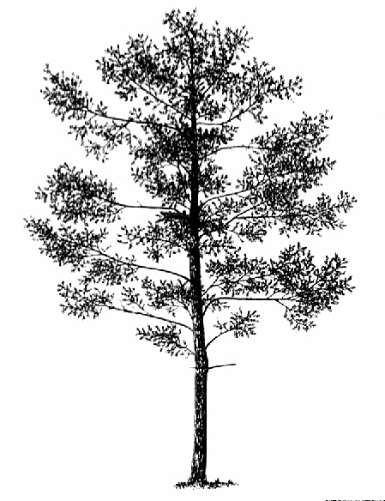
Directions: in this activity, you will be determining how many trees you would have to plant per year to completely offset the CO₂ emissions for an average school bus. To do so, you will choose a tree from your school’s campus (or one nearby) and determine how much CO₂ it absorbs in a given year. You will then use data about the average CO₂ emissions from a school bus to determine how many of these trees it would take to completely absorb this CO₂ by photosynthesis.
Image source: conifers.org

- Determine the diameter (width) of your tree’s canopy: Work with a partner. You will need a ball of string and a meter stick or measuring tape. One person (Partner A) should stand under the edge of the tree’s canopy (the furthest point from the trunk that leaves are found) and hold the ball of string. The other person (Partner B) should unwind the string and walk past the tree trunk to the edge of the canopy directly across from the first person. Mark the edge of the canopy on the string and use a meter stick or measuring tape to measure the diameter of the canopy in meters. It may be easier to measure in centimeters and then divide by 100. *Your instructor may decide to provide the size of the tree for you in advance. This is recommended if another lab is occurring at the same time.
- What is the diameter (width) of your tree’s canopy? meters
- What is the radius of your tree’s canopy? To calculate the radius of the tree’s canopy, divide the diameter in half.
Diameter: ______________ m ÷ 2 = m (Radius of tree’s canopy)
- What is the total area of your tree’s canopy? To calculate the total area of the tree’s canopy, square the radius and multiple it by pi (3.14).
Radius Squared = m² (e.g. if your radius was 2 m, this would be 2 x 2 = 4 m²)
Squared Radius x 3.14 = m² (Total area of the tree’s canopy)
- Next we need to determine how much CO₂ is absorbed by the tree per year. A typical tree will absorb 0.205 kg (0.5 lbs.) of CO₂ per square meter of tree canopy. To determine how much CO₂ that our tree will absorb per year, we have to multiply the total area of the tree’s canopy that we calculated in the previous question by 0.205 kg.

Total Area of the Canopy: x 0.205 kg =
This is the amount of CO₂ sequestered by this particular tree in a given year.↑
- A school bus emits an average of 17,237 kg (38,000 lbs.) of CO₂ per year. How many trees of this size would it take to sequester the average annual emissions of one school bus?
^{Show your work!}
- If the tree that is sequestering the CO2 from our bus is cut down and burned, what happens to the CO₂ that it absorbed?
- School buses transport roughly 26 million students per year. On average, school buses get an average of 7 miles of transportation for every gallon of diesel fuel. The average privately-owned vehicle gets 20.8 MPG. Would it be better for students to be driven to school (or drive themselves) than for them to take a bus?
Keep in mind that the average school bus transports 36 students. When students are driven to school, the average privately-owned vehicle transports 1.5 students over a 10-mile roundtrip between home and school. This information is summarized in the table below. Which would be more efficient, transporting students by bus or by a privately-owned vehicle?
 | Bus | Car
Average Number of Students Transported | 36 | 1.5
Average Miles Per Gallon by Vehicle | 7 | 20.8
Gal of Fuel Used Per Bus/car Per School Year | 1714.00 | 86.50
Average Gal of Fuel Used Per Student Per Year | 47.6 | 57.7
Data taken from http://www.americanschoolbuscouncil.org/issues/environmental-benefits
It would be more efficient to transport students by .
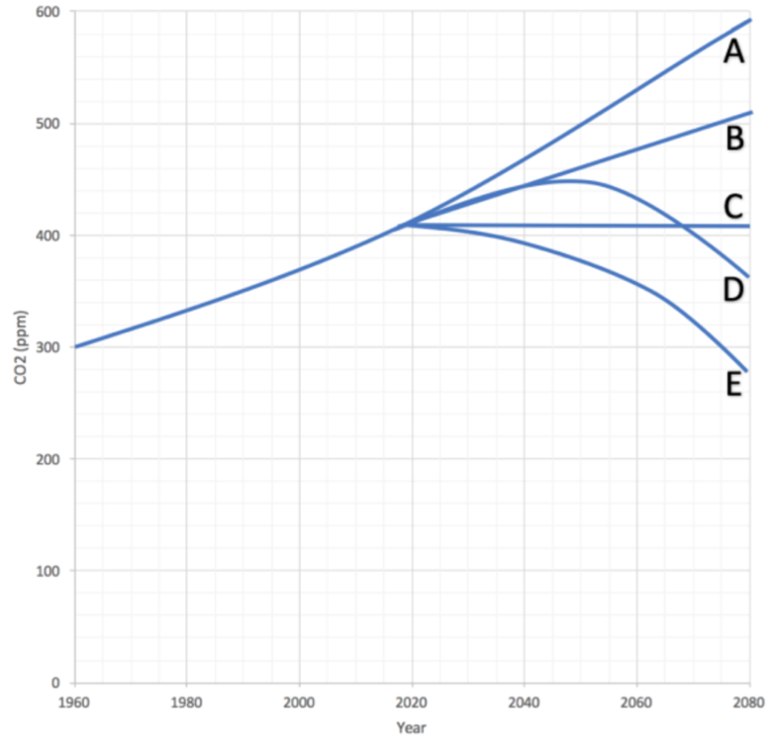
- In 2014, the US emitted a total of 5.4 trillion kg (12 trillion lbs.) of CO₂ from energy production and use. Based on your data, how many trees of this size would be needed each year to offset these emissions?
^{Show your work!}
- If we were to cut total global fossil fuel use in half overnight (and keep our usage at this level indefinitely), what would happen to CO₂ levels in the atmosphere? Choose one of the options below & justify w/ evidence.
I chose because
By now it might seem evident that in most cases we do not have enough open space to plant a sufficient number of trees to absorb all of the CO₂ from student transportation, let alone from the rest of human activity. However, there are other ways in which a person’s carbon footprint can be reduced besides planting trees. The table below has estimations of the extent to which the CO₂ emissions from your lifestyle could be reduced from simple lifestyle changes.
Sustainable Behavioral Choices to Offset School Bus Emissions | Equiv. kg CO_{2 (per year)} | % of Annual  Avg Bus Emissions per Student | % of Avg American's Emissions  _{(per year)}
Biking/Walking to school 1 day a week for a year (average) | -64.0 | 20% | 0.32%
Biking/Walking to school every day for a year (average) | -319.3 | 100% | 1.60%
Using cold water to wash clothes and a low-flow showerhead for a year | -148.3 | 46% | 0.74%
Eliminating beef from your diet for one year | -489.9 | 153% | 2.45%
Eliminating red meat from your diet for one year | -747.1 | 234% | 3.74%
Practicing a "Meatless Monday" diet every week for a year | -111.1 | 35% | 0.56%
Adopting a vegetarian diet (still includes eggs & dairy) for a year | -865.9 | 271% | 4.34%
Reducing portions to USDA-recommended serving sizes of meat, poultry, & eggs | -369.2 | 116% | 1.85%
Avoiding air travel for one year (assuming average US flyer miles) | -89.8 | 28% | 0.45%
Avoiding a transatlantic flight for a given year | -758.9 | 238% | 3.80%
Using a fan instead of an AC window unit (per resident; summer nights only) | -511.7 | 160% | 2.56%
Using a fan instead of central AC (per resident; summer nights only) | -506.2 | 159% | 2.54%
Using a clothesline instead of a dryer for 6 months (per resident) | -106.6 | 33% | 0.53%
Observing posted speed limits for one year (for average driving statistics) | -327.5 | 103% | 1.64%
Choosing a 10% Renewable Energy Utility Option (per resident) | -226.3 | 71% | 1.13%
Switching a home's energy to carbon-neutral energy (per resident) | -2265.5 | 709% | 11.34%
75% reduction of "Standby Power" used by appliances for 1 year (per resident) | -127.5 | 40% | 0.64%
Reducing your daily shower time by 5 minutes | -372.4 | 117% | 1.87%
Switching one 75-watt incandescent bulb for a CFL (bulb's lifetime) | -369.2 | 116% | 1.85%
Only using a hand dryer at school restroom (4x/day, weekdays) | -19.1 | 6% | 0.09%
Switching to LED Christmas lights instead of traditional lights (per resident) | -83.0 | 26% | 0.42%
Choosing no-rush shipping for a year of online purchases (for twenty-1 lb. Packages) | -384.2 | 120% | 1.92%
Setting a thermostat 2 degrees warmer in summer and 2 degrees cooler in winter (per resident) | -348.8 | 109% | 1.75%
Properly insulating a water heater & reducing the max temp < 120 deg. (per resident) | -323.0 | 101% | 1.62%
Limiting daily television time to 2 hours (vs. avg of 6 hours/day) for one year | -53.5 | 17% | 0.27%

A more complete version of this table with sources of information for this data can be found at http://wuhsag.weebly.com/uploads/1/4/0/9/14095127/2017-7-17_co2_equivalents_table.xlsx

- Using the table on the previous page, choose up to 6 activities that you personally could adopt in order to reduce your lifestyle’s CO₂ emissions by 318 kg (700 lbs.) or more. (318 kg of CO₂ is what the average student creates per year when they ride the bus to school and will serve as the baseline for this activity).
Keep in mind that you can only choose activities that could apply to your own lifestyle. For example, if it is unlikely that your family will switch to a source of energy for your home that is completely carbon-neutral within the next year, you cannot choose that item as an option. You can also only choose activities that are not currently a part of your lifestyle (the goal is to reduce your lifestyle by an additional 318 kg). Choose options until you reach 318 kg (700 lbs.) of CO₂ or more.
Option 1:
Kilograms of CO₂ reduced: % of Average American’s Emissions:
Option 2:
Kilograms of CO₂ reduced: % of Average American’s Emissions:
Option 3:
Kilograms of CO₂ reduced: % of Average American’s Emissions:
Option 4:
Kilograms of CO₂ reduced: % of Average American’s Emissions:
Option 5:
Kilograms of CO₂ reduced: % of Average American’s Emissions:
Option 6:
Kilograms of CO₂ reduced: % of Average American’s Emissions:
- If we wanted to completely negate the amount of CO₂ produced by an average American lifestyle, how many kilograms of CO₂ would we have to eliminate?
Show your work! Note that the table shows bus emissions are 1.6% of an average American’s emissions. How can you use math to turn 1.6% into 100%?

Day 4-5: Individual Sustainability Goals
Directions: Now that you are more aware of the impact of your lifestyle on natural systems, you will be developing five goals to help improve the sustainability of your lifestyle. Your challenge is to practice these goals for one week (7 days and nights). You will be asked at some point to reflect on your progress in order to help you determine whether or not you can be successful. Your goals should be reflective of changes that you personally could make that you are not already doing that would have as much improvement to the sustainability of your lifestyle while still being feasible enough to adopt permanently.

Goal 1: For one week, I will
This will improve the sustainability of my lifestyle because
Goal 2: For one week, I will
This will improve the sustainability of my lifestyle because
Goal 3: For one week, I will
This will improve the sustainability of my lifestyle because
Goal 4: For one week, I will
This will improve the sustainability of my lifestyle because
Goal 5: For one week, I will
This will improve the sustainability of my lifestyle because
Goal Follow-up: after a period of 1-7 days, discuss the questions below in small teams and/or as a class.
- For which of your goals were you completely successful?
- For which of your goals were you unsuccessful?
- Why were you unsuccessful? For each goal that did not have a successful outcome, summarize the obstacles that prevented your success.
- What can you change in order to be more successful in the future? Re-develop your goals so that you can be successful in improving your likelihood of improving the sustainability of your lifestyle.

5406 million metric tons. Source: U.S. Energy-Related Carbon Dioxide Emissions, 2014 http://www.eia.gov/environment/emissions/carbon/

